Retention Analytics using Propensity ML Models

Research Documentation for Customer Churn Prediction

Prepared for Mercer Superannuation Use Case

1. Introduction
Retention analytics focuses on identifying customers who are likely to leave a company or discontinue services. In industries such as superannuation, banking, insurance, telecom, and subscription-based businesses, retaining customers is critical because acquiring new customers is more expensive than retaining existing ones.
Machine Learning (ML) based propensity models help organizations predict customer behavior by analyzing historical customer data and identifying patterns that indicate churn risk.
For Mercer Superannuation, retention analytics can help:
- Identify members likely to transfer funds to another provider
- Detect disengaged customers
- Improve customer satisfaction
- Increase long-term member retention
- Enable proactive retention strategies

2. What is Propensity Modeling?
Propensity modeling is a Machine Learning approach used to predict the likelihood or probability of a customer performing a specific action.
Examples:
- Propensity to churn
- Propensity to buy
- Propensity to renew
- Propensity to respond to marketing campaigns
In this use case:
Propensity to Churn = Probability that a customer may leave

3. Retention Analytics Workflow
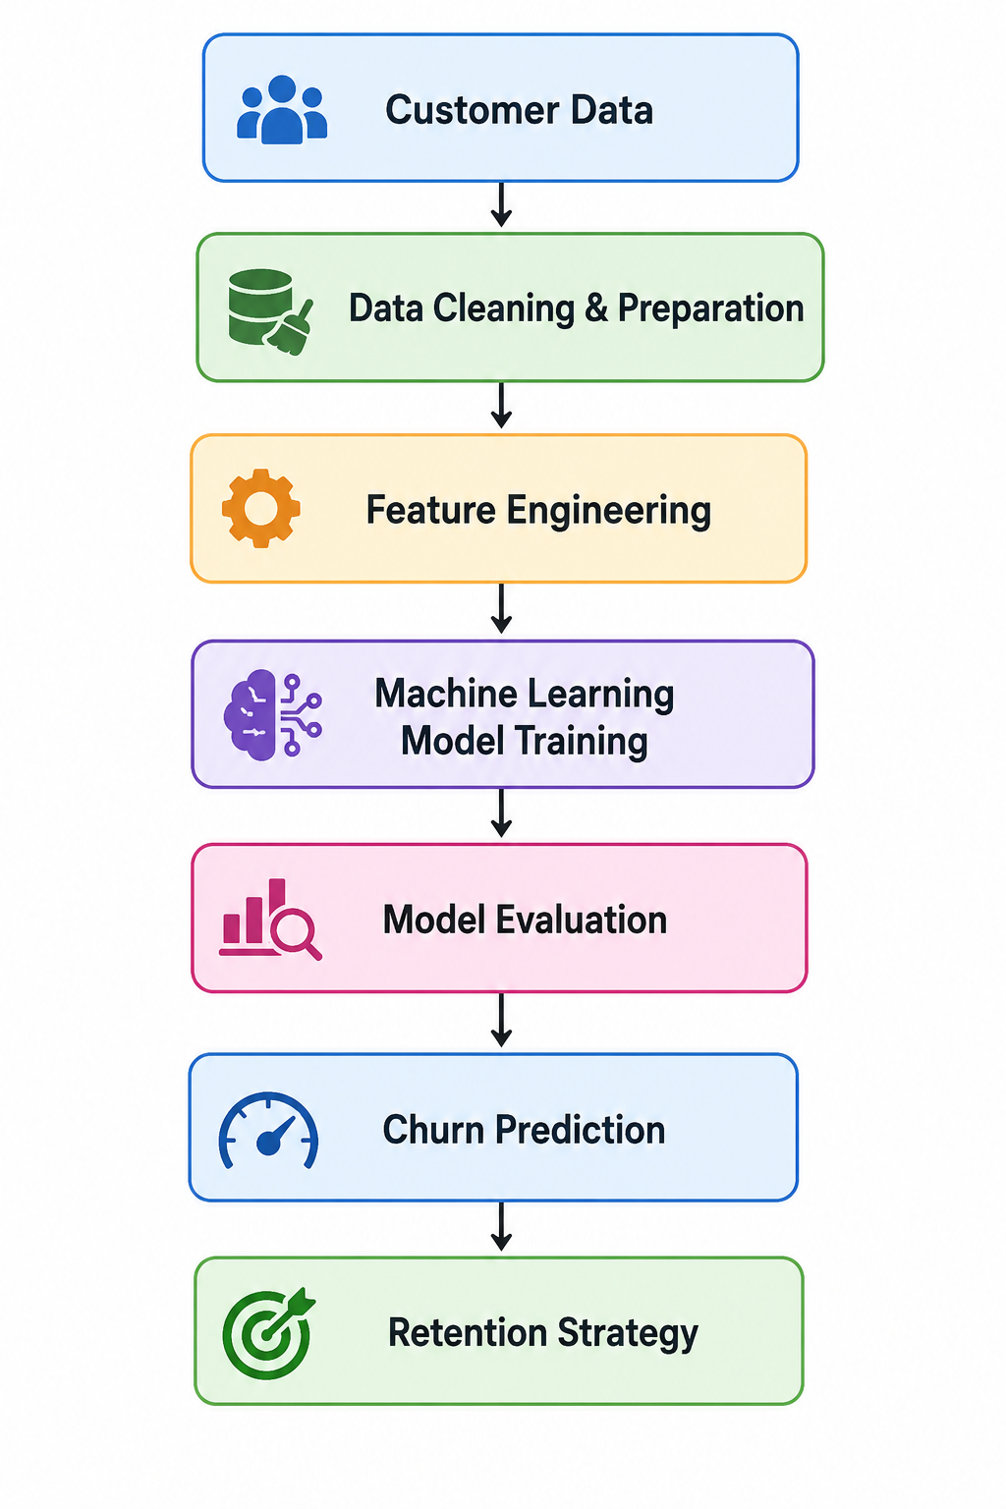

4. Common Data Used for Customer Retention Analytics
Typical customer attributes used for churn prediction:
Category | Example Fields
Customer Information | Age, Gender, Employer Type
Financial Information | Super Balance, Contribution Amount
Behavioral Data | Portal Logins, Mobile App Usage
Support Data | Customer Support Calls
Investment Information | Investment Plan Type, Risk Profile
Engagement Data | Adviser Interactions

5. Machine Learning Algorithms for Retention Analytics

5.1 Logistic Regression

Overview
Logistic Regression is a basic classification algorithm used for predicting binary outcomes such as:
Churn / No Churn
Yes / No
Stay / Leave
It calculates the probability of a customer leaving based on input features.

Simple Example
Low app usage
+ many complaints
+ low investment returns
= high churn probability
Example prediction:
Customer churn probability = 82%

Advantages
- Simple and easy to understand
- Fast model training
- Good baseline model
- Easy interpretation

Disadvantages
- Cannot handle highly complex customer behavior
- Lower accuracy compared to advanced ensemble models

Suitability for Retention Analytics
Useful as:
- Initial baseline model
- Simple churn prediction use cases
- Explainable ML implementation

5.2 Decision Tree

Overview
Decision Tree works like a flowchart and makes decisions by asking multiple questions step-by-step.

Simple Example
Does customer use mobile app frequently?
↓
NO
↓
Many support calls?
↓
YES
↓
Customer may churn

Advantages
- Easy to visualize
- Easy business interpretation
- Handles categorical and numerical data

Disadvantages
- High risk of overfitting
- Single tree may become unstable

Suitability for Retention Analytics
Useful for:
- Business explanation
- Rule-based customer analysis
- Small and medium datasets

5.3 Random Forest

Overview
Random Forest is an ensemble algorithm that combines multiple Decision Trees.
Each tree predicts churn independently, and the final prediction is based on majority voting.

Simple Example
Tree 1 → Churn
Tree 2 → Stay
Tree 3 → Churn
Tree 4 → Churn

Final Result → Churn

Advantages
- High prediction accuracy
- Handles complex customer behavior
- Reduces overfitting
- Provides feature importance
- Suitable for structured business data

Disadvantages
- Slightly slower than simple models
- More difficult to explain internally compared to Logistic Regression

Suitability for Retention Analytics
Highly suitable because it:
- Handles multiple customer factors effectively
- Works well for churn prediction
- Supports feature importance analysis

5.4 XGBoost (Extreme Gradient Boosting)

Overview
XGBoost is an advanced boosting algorithm widely used in enterprise Machine Learning systems.
It improves prediction accuracy by continuously learning from previous prediction mistakes.

Simple Example
If earlier predictions failed to identify churn customers correctly, the next model iteration focuses more on those incorrect predictions.

Advantages
- Very high prediction accuracy
- Excellent performance for tabular business data
- Handles complex customer patterns

Disadvantages
- More complex implementation
- Requires parameter tuning
- Longer training time

Suitability for Retention Analytics
Very suitable for:
- Enterprise-level churn prediction
- Large customer datasets
- Advanced predictive analytics systems

5.5 Neural Networks

Overview
Neural Networks are Deep Learning models inspired by the structure of the human brain.
They identify hidden and highly complex patterns in customer data.

Advantages
- Handles very large datasets
- Learns complex hidden relationships
- Powerful predictive capability

Disadvantages
- Difficult to interpret
- Requires large datasets
- High computational cost

Suitability for Retention Analytics
Useful for:
- Large-scale enterprise systems
- Advanced AI-based customer analytics

6. Comparison of ML Models for Retention Analytics
Algorithm | Complexity | Accuracy | Explainability | Best Use Case
Logistic Regression | Low | Medium | High | Baseline prediction
Decision Tree | Medium | Medium | High | Rule-based analysis
Random Forest | Medium | High | Medium | Practical churn prediction
XGBoost | High | Very High | Medium | Enterprise analytics
Neural Networks | Very High | Very High | Low | Large-scale AI systems

7. Recommended Algorithm for Mercer Superannuation
Based on the retention analytics use case, the recommended starting algorithm is:

Random Forest

Reasons
- Good prediction accuracy
- Handles structured business/customer data effectively
- Supports feature importance analysis
- Less overfitting compared to Decision Trees
- Easier implementation compared to XGBoost
- Suitable for churn prediction and customer retention analytics

8. Example Customer Churn Prediction Factors
Important churn indicators identified in typical retention analytics models:
Feature | Business Meaning
Investment Return Percentage | Low returns may increase churn
Customer Support Calls | High complaints may indicate dissatisfaction
Portal Login Frequency | Low engagement may indicate churn risk
Mobile App Usage | Low usage may indicate disengagement
Membership Tenure | New members may churn more easily

9. Business Benefits of Retention Analytics
Retention analytics helps organizations:
- Improve customer retention
- Reduce customer loss
- Increase long-term revenue
- Improve customer engagement
- Identify at-risk customers early
- Enable targeted retention campaigns

10. Future Enhancements
Possible future improvements:
- Real-time churn prediction
- AI-powered retention recommendations
- Personalized customer engagement
- Integration with Databricks AutoML
- MLOps-based monitoring and retraining

11. Conclusion
Retention analytics using propensity Machine Learning models enables organizations to proactively identify customers who are likely to churn. Multiple ML algorithms can be used for churn prediction, including Logistic Regression, Decision Trees, Random Forest, XGBoost, and Neural Networks.
Among these, Random Forest provides the best balance between prediction accuracy, implementation simplicity, and business interpretability for customer retention analytics use cases such as Mercer Superannuation.
Advanced algorithms such as XGBoost can further improve performance for large enterprise datasets and production-grade AI systems.

